**Misael Morales and Oriyomi Raheem**

**Homework No. 1 Solution**

**PGE385K (Unique No. 20274)**

**Fall Semester 2023**

**Advanced Multi-Well Formation Evaluation**

**1. Download the example LAS file and core data accompanying this homework project. Plot the core data together with the well logs and depth-shift them if necessary. Discard/flag measurements with dubious quality.**

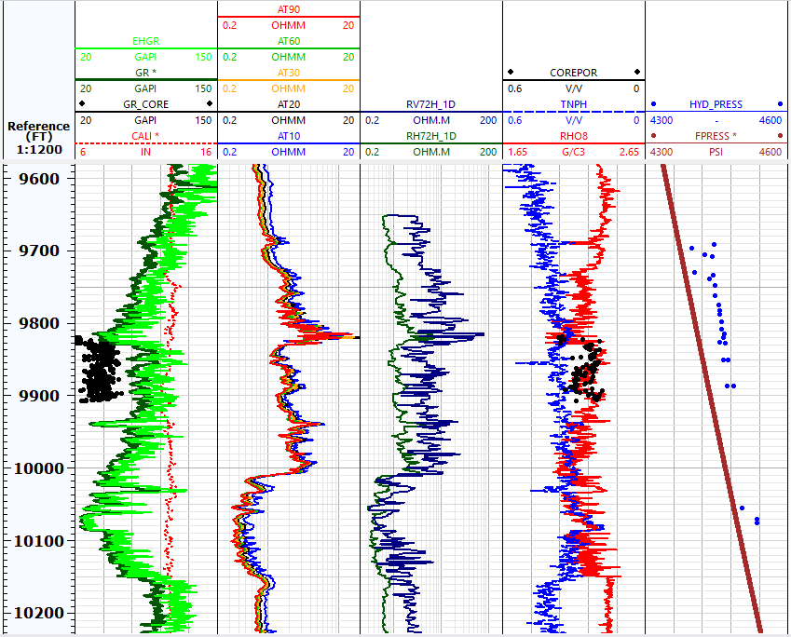

The logs and core are in-depth and don’t require depth shifting. The separation in vertical and horizontal resistivities indicates laminated shale.

**2. Consider the depth interval between 9,600 and 10,200 ft MD.**



**3. Identify lithology, water zones, and possible hydrocarbon zones. Make use of cross-plots to guide your analysis. What possible type of outcrop and sedimentary sequence do the well logs and core photographs indicate?**

**Lithology**

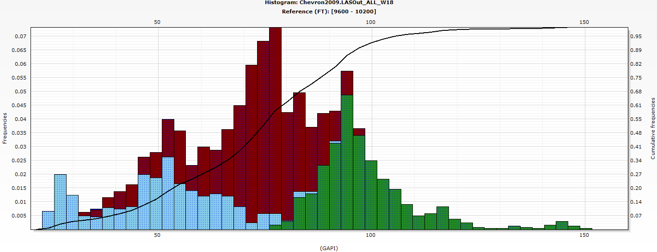

**Core Photographs**

The core photograph below indicates the presence of very thin shale-sand laminations.

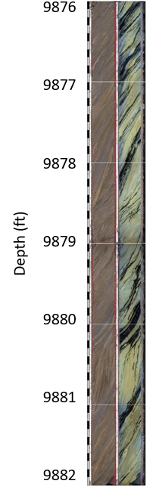

**Fluid Zones**

In the cross plot of deep resistivity versus gamma-ray below, the section highlighted blue represents water sands, brown represents light fluids sands and green represents shale

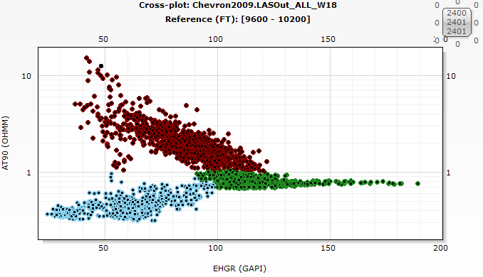

The hydrocarbon zone spans from 9720 to 10010 ft and the water leg can be found between 10030 to 10150 ft.

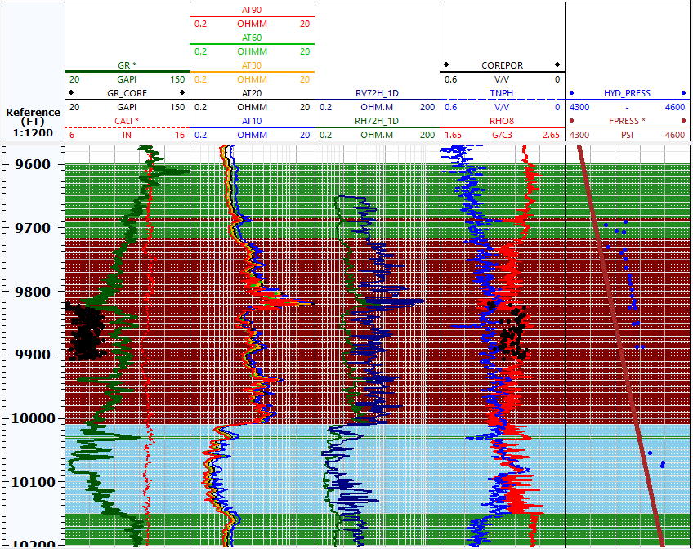

The sedimentary sequence is a shale-sand sequence. The sand zone has an overlaying top shale and an underlying bottom shale.

Anisotropy and Lamination Characterization

The cross plot below shows that the formation is anisotropic because the resistivities do not fall on the 45-degree line. In this low-resistivity pay (LRP) formation, the sands are interlayered sands with shale lamina and the effective resistivity can be resolved from the vertical and horizontal resistivity.

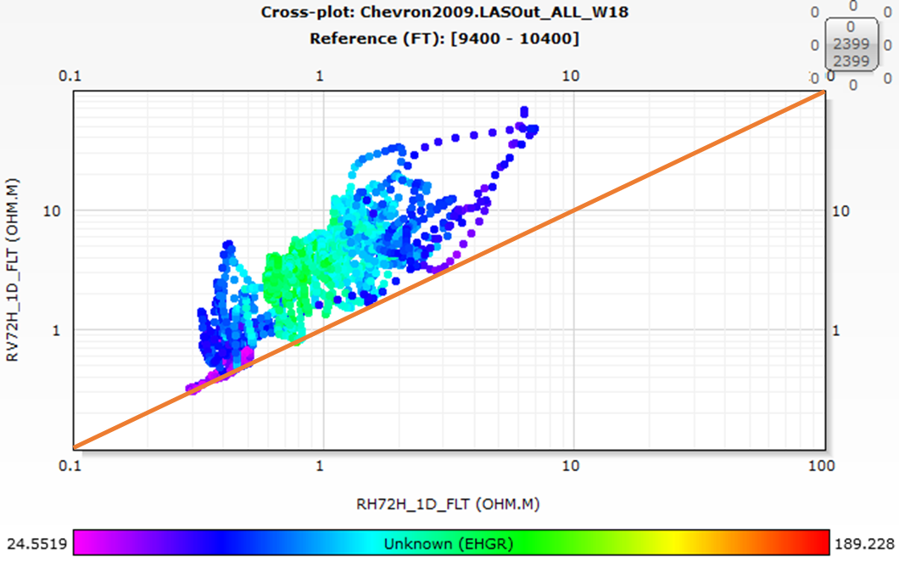

**4. Verify that the gamma ray log truly responds to shale concentration.**

**Estimate volumetric concentration of shale by two different methods.**

**Shale Characterization**

**Diagnose whether shale distribution is laminar, dispersed (grain-coating clay), or structural. Identify “pure” shale segments in the well and verify that shale properties remain constant with depth within the sedimentary sequence. Identify formation tops for analysis/calculations if deemed necessary.**

**5. Calculate sandstone porosity and fluid density. Compare the calculated porosities to core data, pore pressure gradients, and sonic porosities. Note that this item is related to the items below.**

**6. Using the parallel- and perpendicular-to-bedding-plane resistivities, calculate hydrocarbon pore volume as a function of depth using the interpretation procedure intended for shale-laminated sandstone. Assume that a=1.0, m=2.1, and n=1.9 in sandstones. Calculate hydrocarbon density and compare your calculations to fluid density interpreted from pore-pressure gradients.**

**7. Calculate Sxo. Verify that your calculations of Sw and Sxo are consistent with your calculation of sandstone porosity.**

**8. Explore whether core permeability exhibits a clear correlation with your calculated sandstone porosities and irreducible water saturation.**